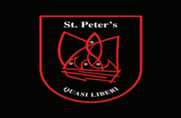

Board of Management Agreed Report November 21st 2023

- Minutes of the September and October meetings were approved by the Board without matter arising
- Correspondence: All correspondence received prior to the meeting was addressed at the meeting
- Principal’s Report: Principal gave an overview of school activities and business in the school for October and November
- Financial Reports : The substitution report and the monthly accounts for October and November were adopted by the board
- The work and commitment of the staff in providing such a rich and varied extra and cocurriculur programme for the students was acknowledged by the board
- The child protection oversight report was provided to the board

